**1 .Write a map reduce and pig program to calculate the number of cases investigated under each FBI code**

**USING MAP REDUCE:**

**DRIVER CLASS:**

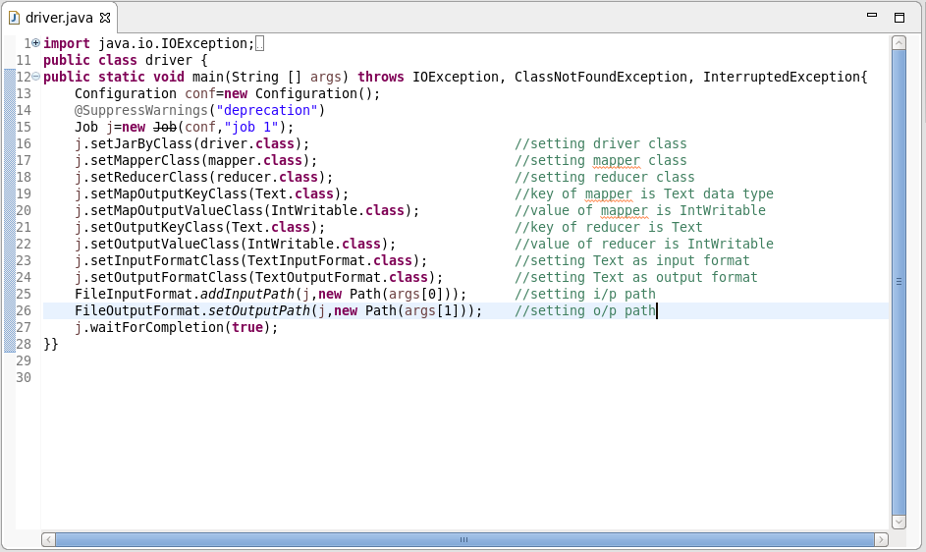

**MAPPER CLASS:**

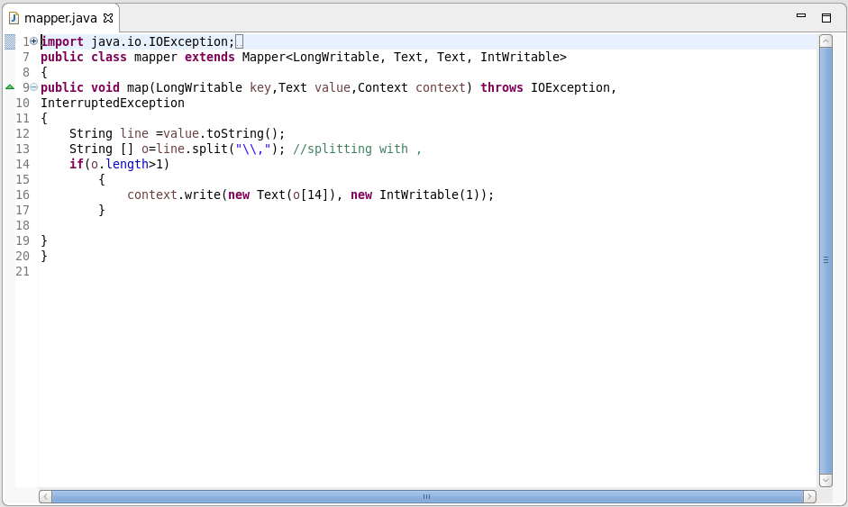

**REDUCER CLASS:**

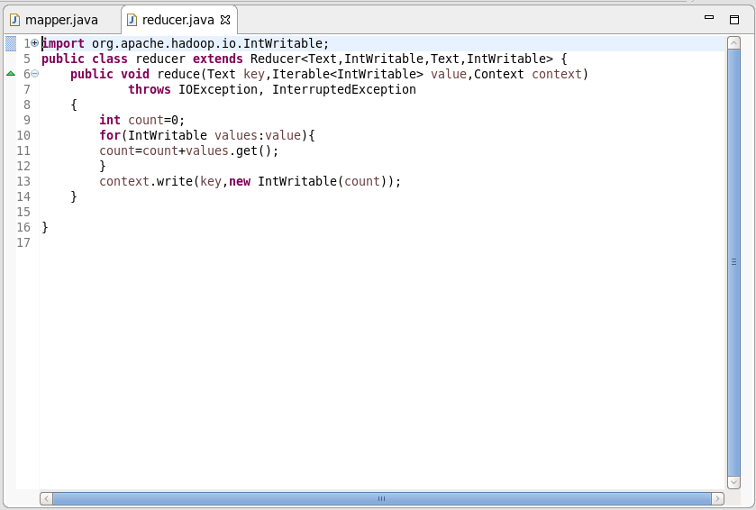

**OUTPUT:**

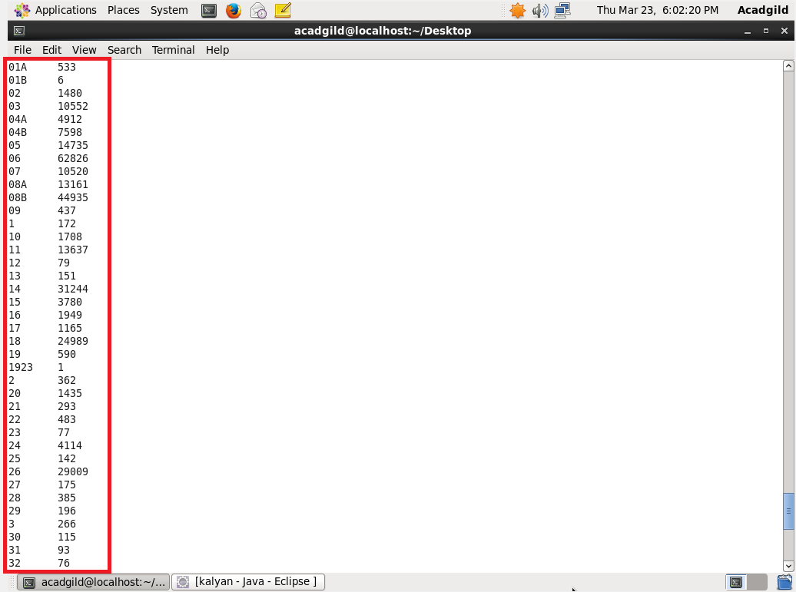

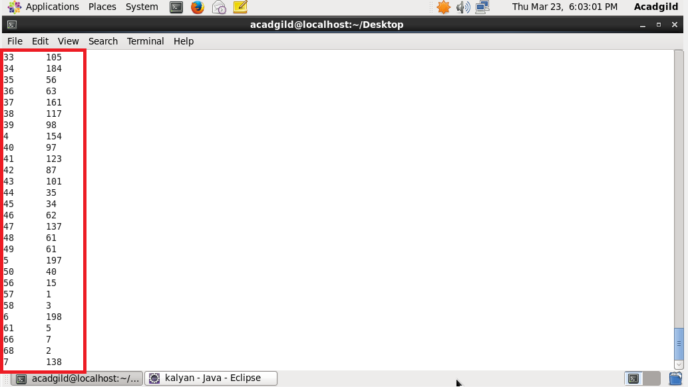

**USING PIG:**

**COMMAND:**

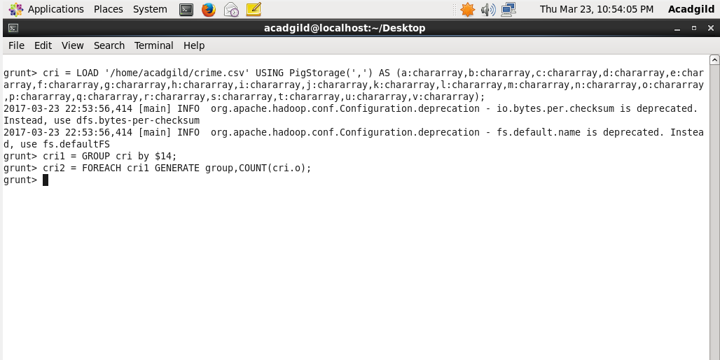

**OUTPUT:**

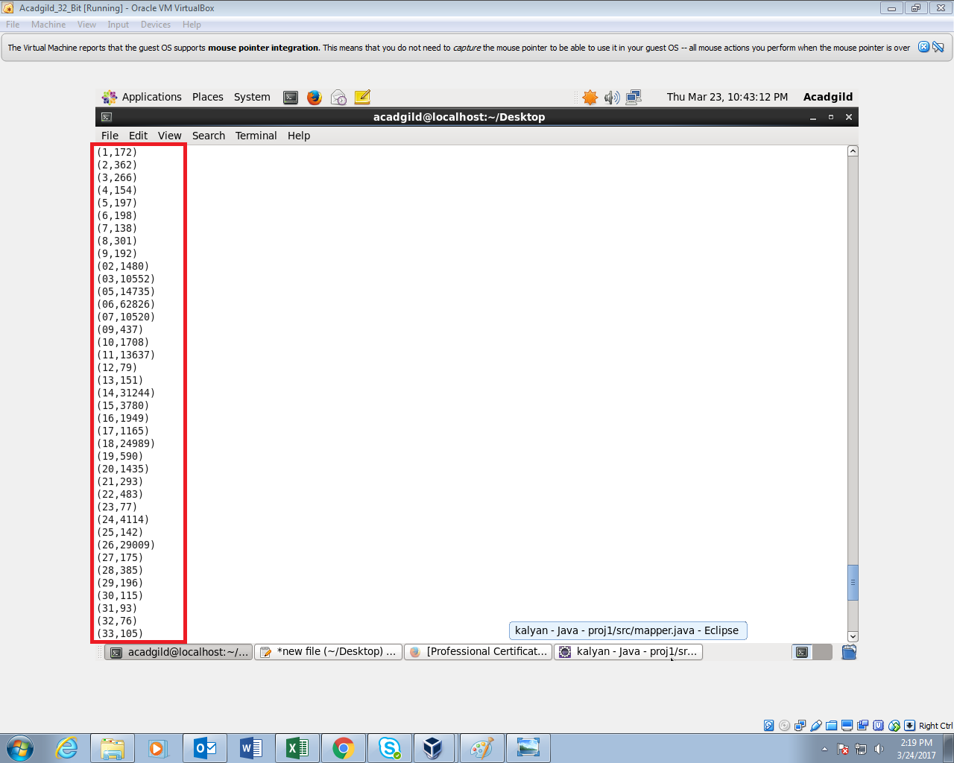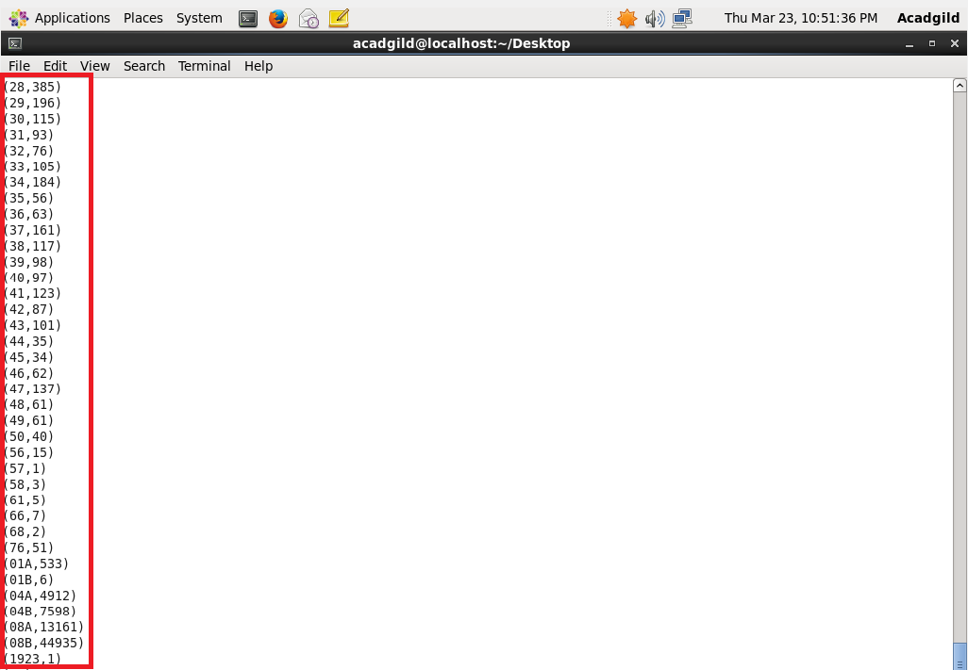

**2. Write a map reduce and pig program to calculate the number of cases investigated under FBI code 32.**

**USING MAPREDUCE:**

**DRIVER CLASS:**

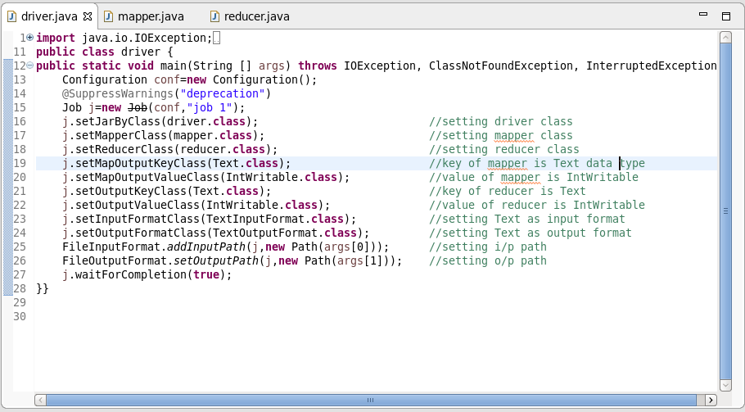

**MAPPER CLASS:**

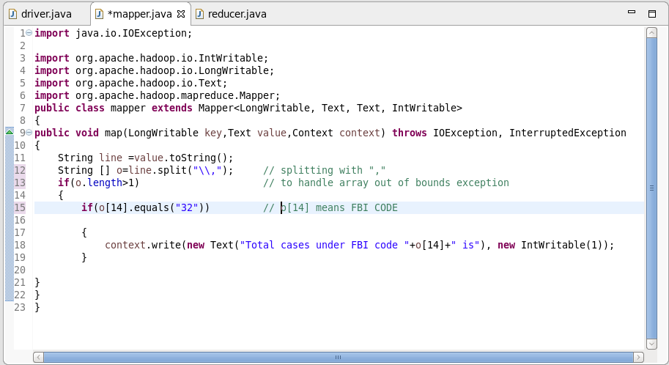

**REDUCER CLASS:**

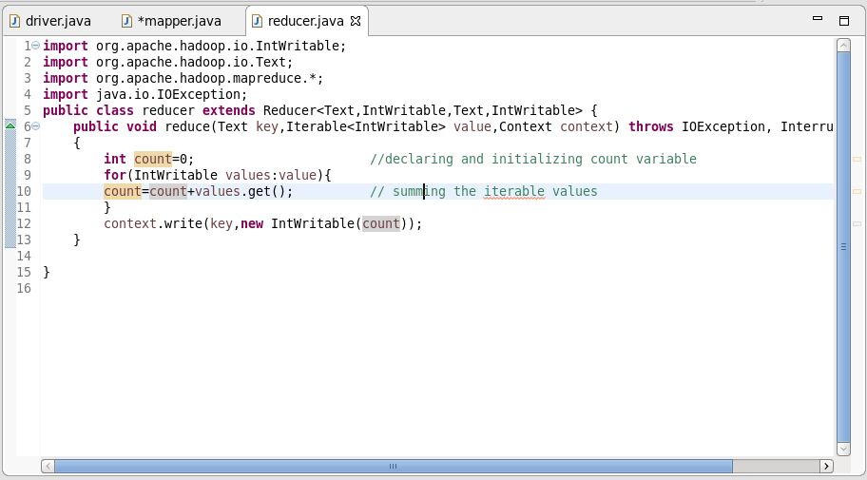

**OUTPUT:**

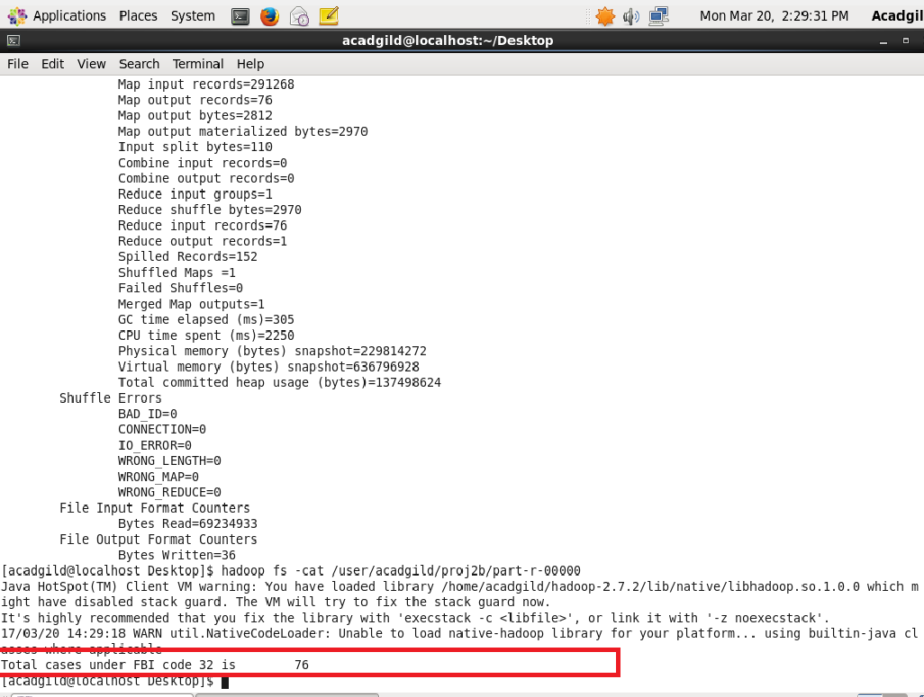

**USING PIG:**

**COMMAND:**

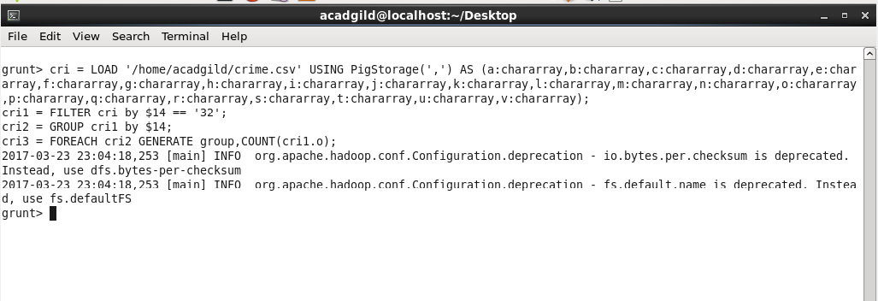**OUTPUT:**

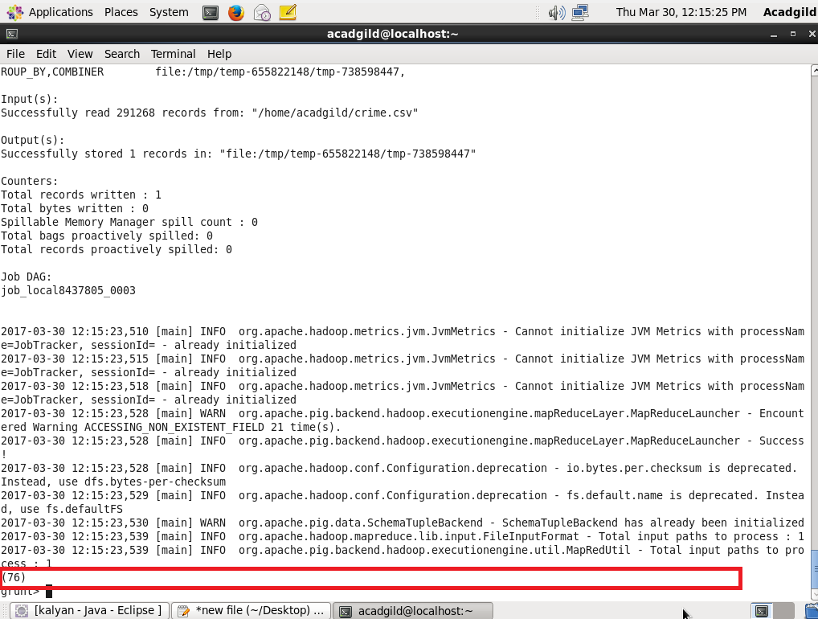

**3. Write a map reduce and pig program to calculate the number of arrests in theft district wise**

**USING MAPREDUCE:**

**DRIVER CLASS:**

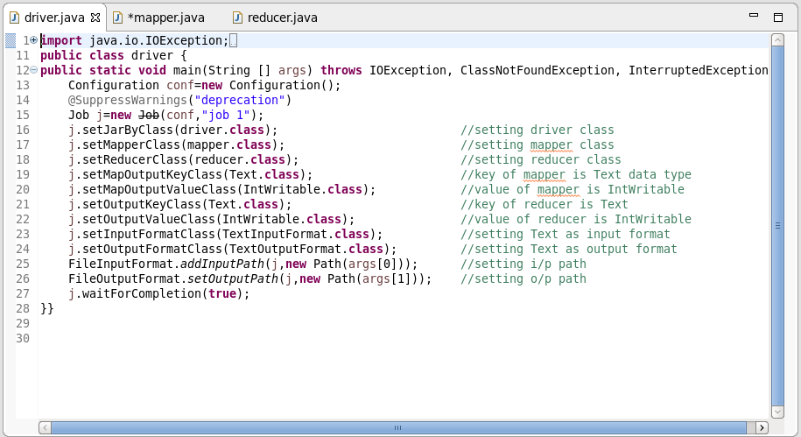

**MAPPER CLASS:**

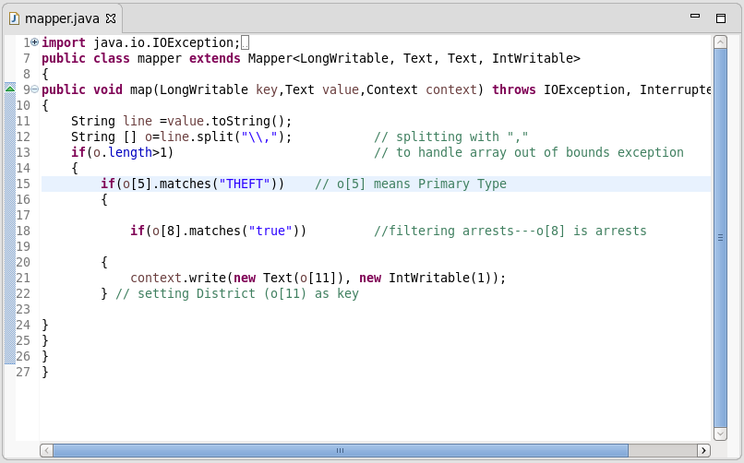

**REDUCER CLASS:**

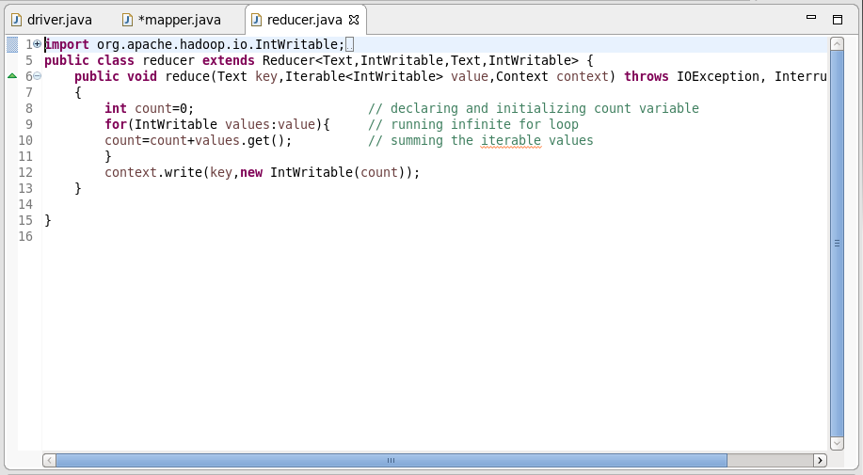

**OUTPUT:**

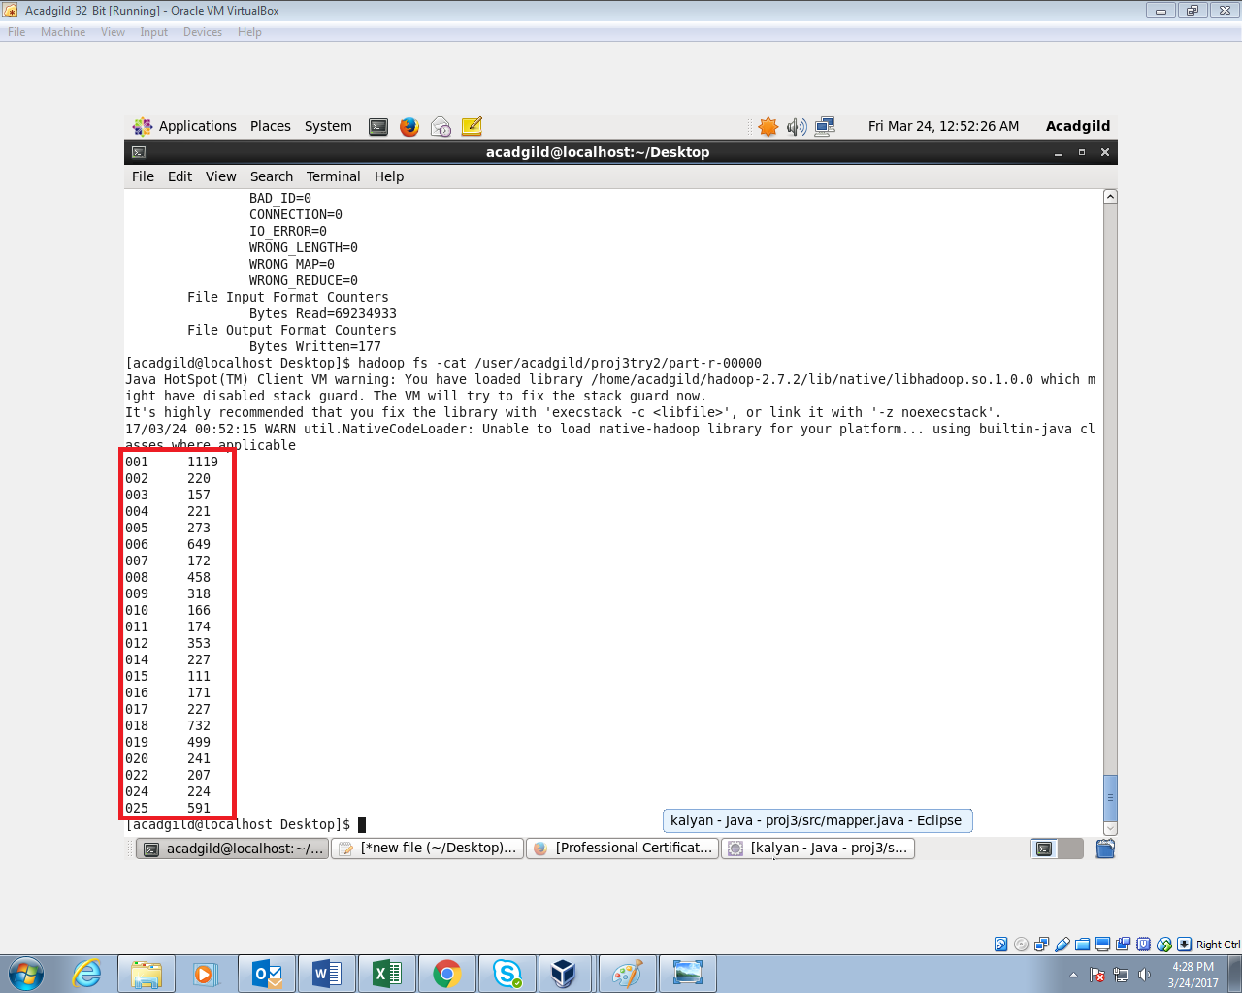

**USING PIG  
  
COMMAND:**

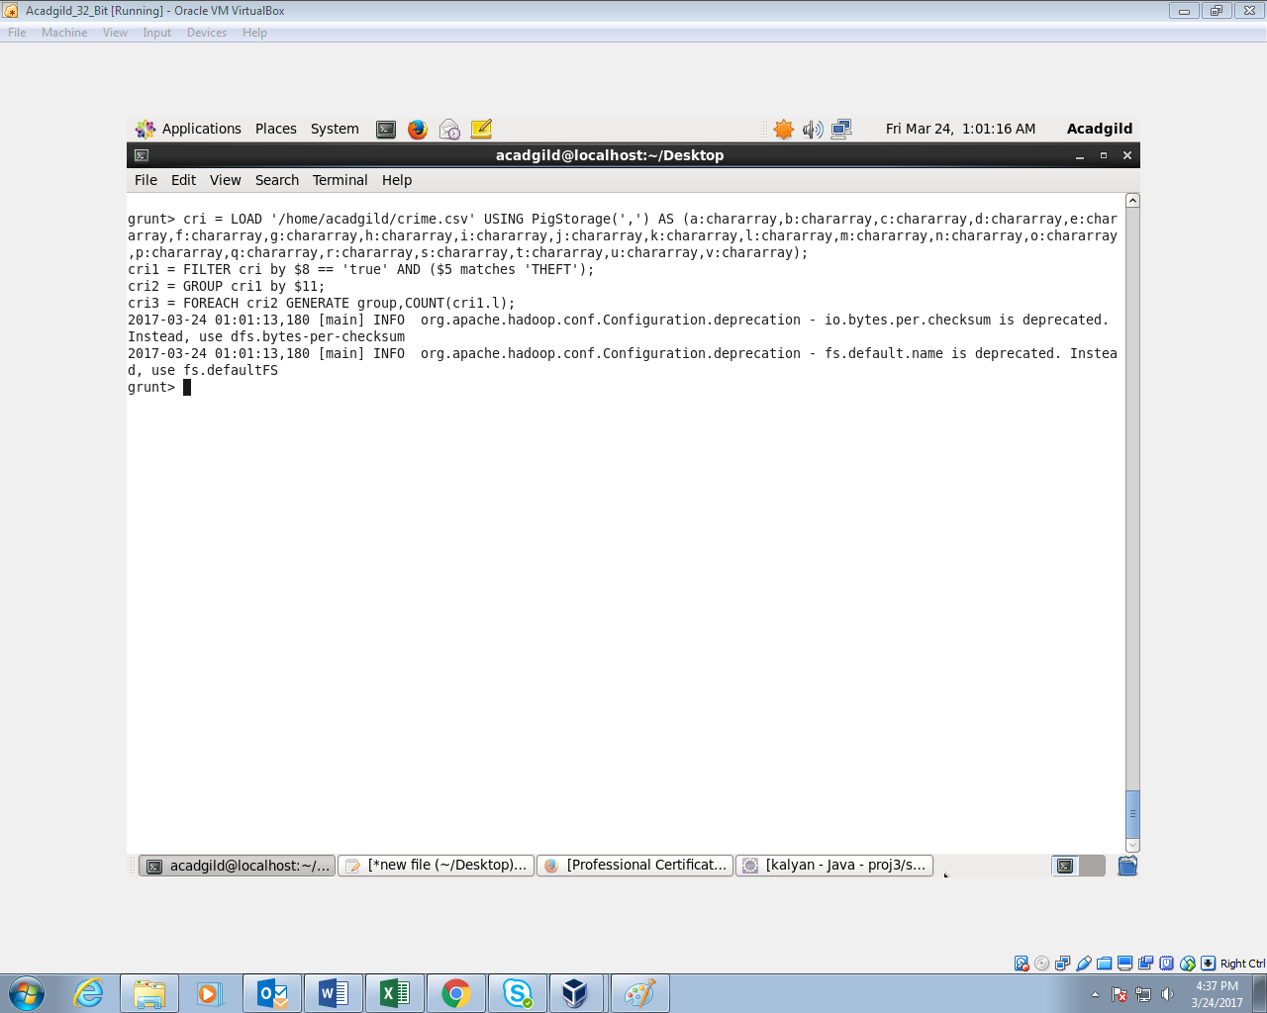

**OUTPUT:**

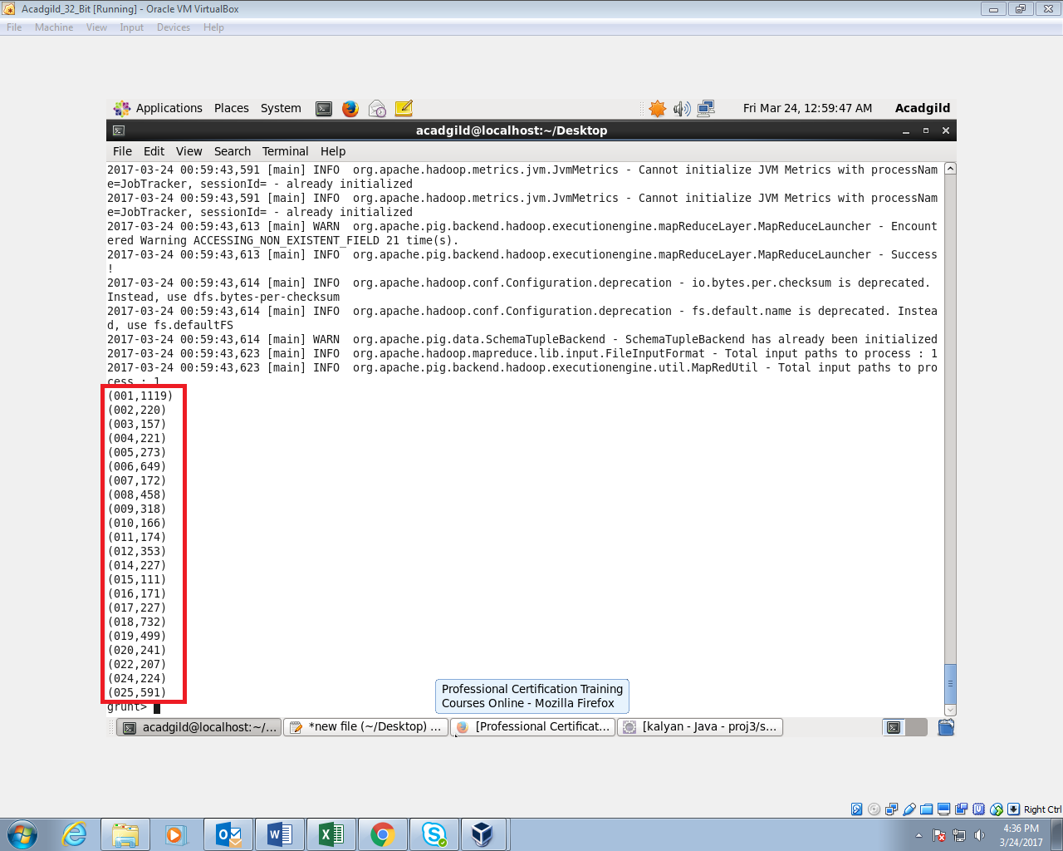

**4. Write a map reduce and pig program to calculate the number of arrests done between October 2014 and October 2015.**

**USING MAPREDUCE:**

**DRIVER CLASS:**

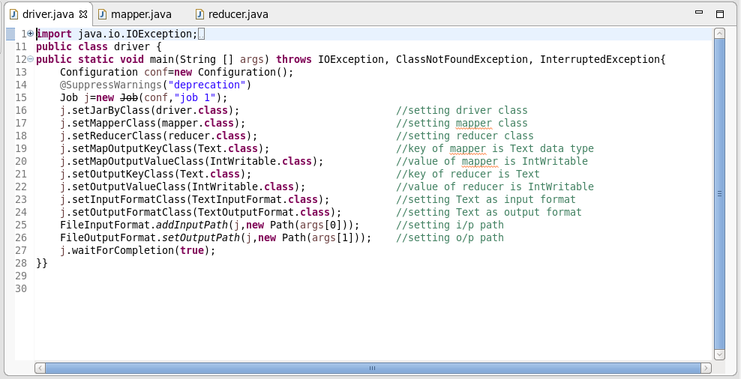

**MAPPER CLASS:**

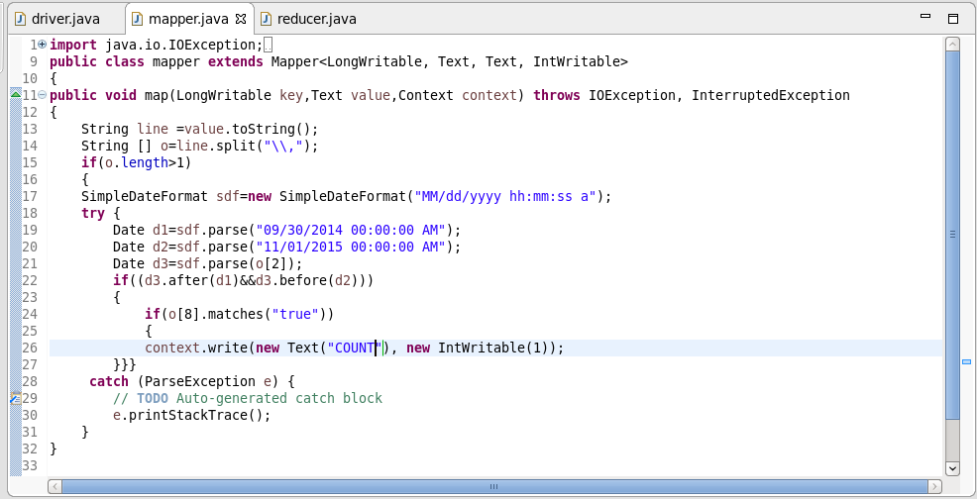

**REDUCER CLASS:**

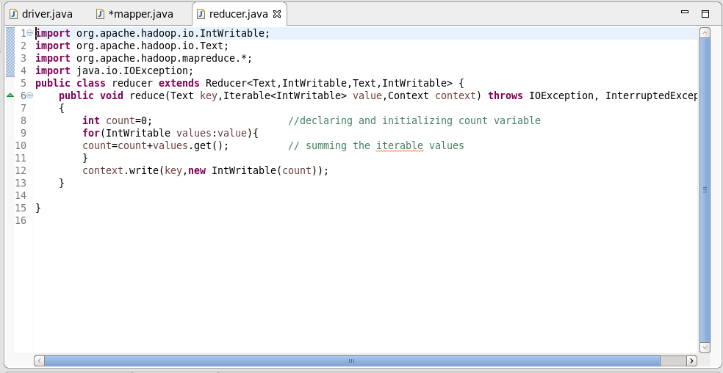

**OUTPUT:**

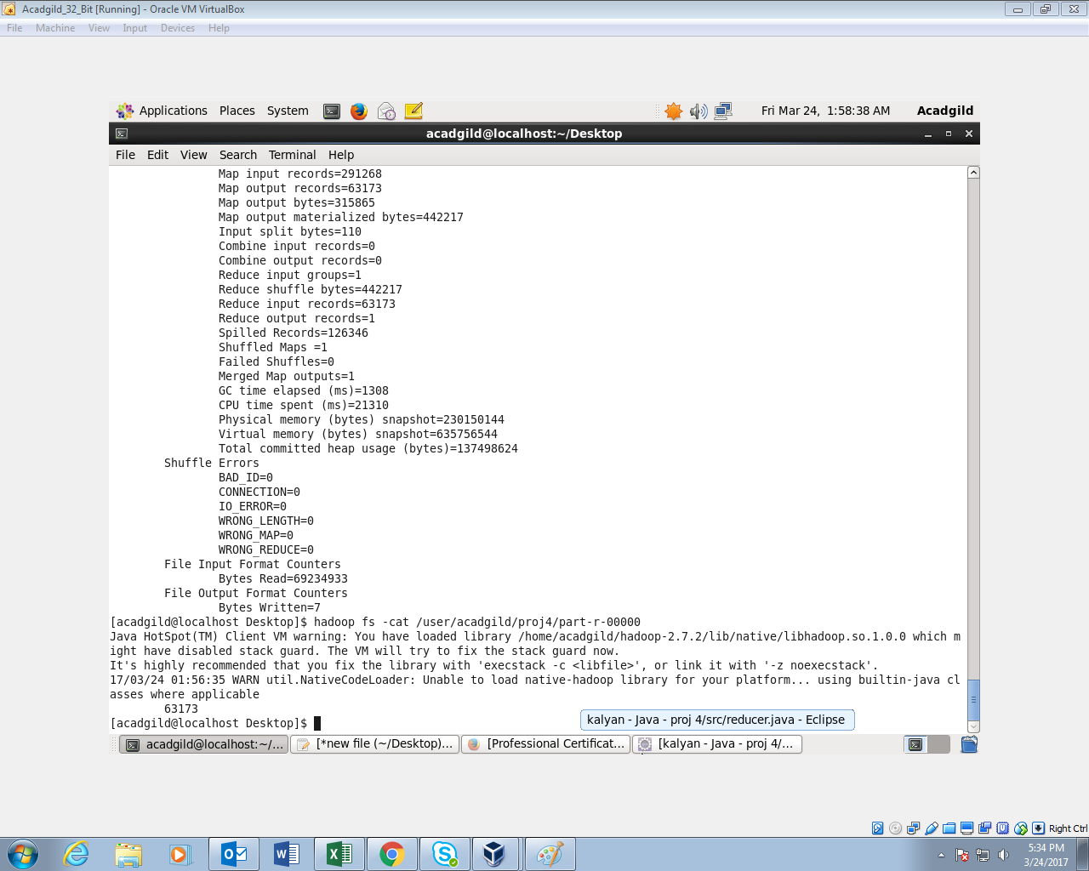

**USING PIG:  
COMMAND:**

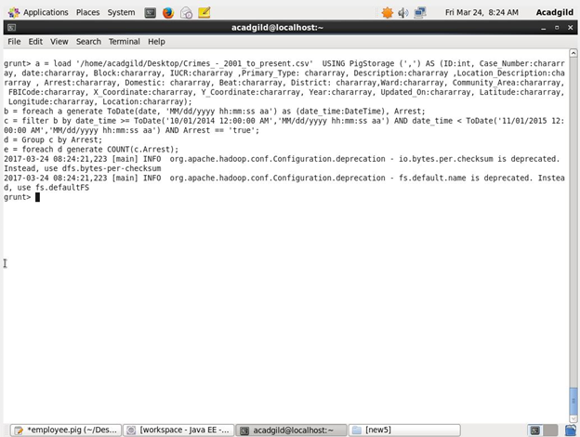

**OUTPUT:**

